Topic- Conditional Branching: Applying if and switch statements, nesting if and else, use of break and default with switch.

What is a Conditional Statement?
In a 'C' program are executed sequentially. This happens when there is no condition around the statements. If you put some condition for a block of statements the flow of execution might change based on the result evaluated by the condition. This process is referred to as decision making in 'C.' The decision-making statements are also called as control statements.
In 'C' programming conditional statements are possible with the help of the following two constructs:
1. If statement
2. If-else statement
It is also called as branching as a program decides which statement to execute based on the result of the evaluated condition.
In this tutorial, you will learn-
- What is a Conditional Statement?
- If statement
- The If-Else statement
- Conditional Expressions
- Nested If-else Statements
- Nested Else-if statements

If statement
It is one of the powerful conditional statement. If statement is responsible for modifying the flow of execution of a program. If statement is always used with a condition. The condition is evaluated first before executing any statement inside the body of If. The syntax for if statement is as follows:
if (condition)
instruction;
The condition evaluates to either true or false. True is always a non-zero value, and false is a value that contains zero. Instructions can be a single instruction or a code block enclosed by curly braces { }.
Following program illustrates the use of if construct in 'C' programming:
#include<stdio.h>
int main()
{
int num1=1;
int num2=2;
if(num1<num2) //test-condition
{
printf("num1 is smaller than num2");
}
return 0;
}
Output:
num1 is smaller than num2
The above program illustrates the use of if construct to check equality of two numbers.
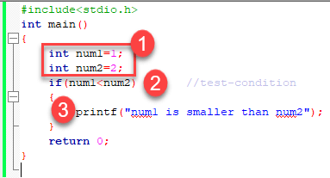
- In the above program, we have initialized two variables with num1, num2 with value as 1, 2 respectively.
- Then, we have used if with a test-expression to check which number is the smallest and which number is the largest. We have used a relational expression in if construct. Since the value of num1 is smaller than num2, the condition will evaluate to true.
- Thus it will print the statement inside the block of If. After that, the control will go outside of the block and program will be terminated with a successful result.

Relational Operators
C has six relational operators that can be used to formulate a Boolean expression for making a decision and testing conditions, which returns true or false :
< less than
<= less than or equal to
> greater than
>= greater than or equal to
== equal to
!= not equal to
Notice that the equal test (==) is different from the assignment operator (=) because it is one of the most common problems that a programmer faces by mixing them up.
For example:
int x = 41;
x =x+ 1;
if (x == 42) {
printf("You succeed!");}
Output :
You succeed
Keep in mind that a condition that evaluates to a non-zero value is considered as true.
For example:
int present = 1;
if (present)
printf("There is someone present in the classroom \n");
Output :
There is someone present in the classroom

The If-Else statement
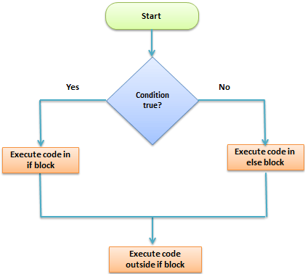
The if-else is statement is an extended version of If. The general form of if-else is as follows:
if (test-expression)
{
True block of statements
}
Else
{
False block of statements
}
Statements;
n this type of a construct, if the value of test-expression is true, then the true block of statements will be executed. If the value of test-expression if false, then the false block of statements will be executed. In any case, after the execution, the control will be automatically transferred to the statements appearing outside the block of If.
Following programs illustrate the use of the if-else construct:
We will initialize a variable with some value and write a program to determine if the value is less than ten or greater than ten.
Let's start.
#include<stdio.h>
int main()
{
int num=19;
if(num<10)
{
printf("The value is less than 10");
}
else
{
printf("The value is greater than 10");
}
return 0;
}
Output:
The value is greater than 10
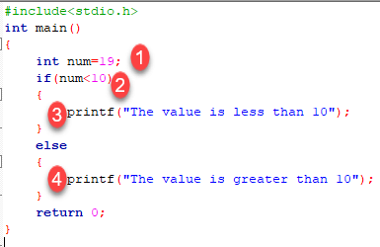
- We have initialized a variable with value 19. We have to find out whether the number is bigger or smaller than 10 using a 'C' program. To do this, we have used the if-else construct.
- Here we have provided a condition num<10 because we have to compare our value with 10.
- As you can see the first block is always a true block which means, if the value of test-expression is true then the first block which is If, will be executed.
- The second block is an else block. This block contains the statements which will be executed if the value of the test-expression becomes false. In our program, the value of num is greater than ten hence the test-condition becomes false and else block is executed. Thus, our output will be from an else block which is "The value is greater than 10". After the if-else, the program will terminate with a successful result.
In 'C' programming we can use multiple if-else constructs within each other which are referred to as nesting of if-else statements.

Conditional Expressions
There is another way to express an if-else statement is by introducing the ?: operator. In a conditional expression the ?: operator has only one statement associated with the if and the else.
For example:
#include <stdio.h>
int main() {
int y;
int x = 2;
y = (x >= 6) ? 6 : x;/* This is equivalent to: if (x >= 5) y = 5; else y = x; */
printf("y =%d ",y);
return 0;}
Output :
y =2

Nested If-else Statements
When a series of decision is required, nested if-else is used. Nesting means using one if-else construct within another one.
Let's write a program to illustrate the use of nested if-else.
#include<stdio.h>
int main()
{
int num=1;
if(num<10)
{
if(num==1)
{
printf("The value is:%d\n",num);
}
else
{
printf("The value is greater than 1");
}
}
else
{
printf("The value is greater than 10");
}
return 0;
}
Output:
The value is:1
The above program checks if a number is less or greater than 10 and prints the result using nested if-else construct.
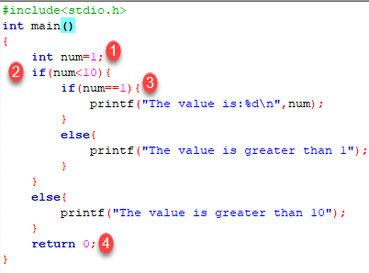
- Firstly, we have declared a variable num with value as 1. Then we have used if-else construct.
- In the outer if-else, the condition provided checks if a number is less than 10. If the condition is true then and only then it will execute the inner loop. In this case, the condition is true hence the inner block is processed.
- In the inner block, we again have a condition that checks if our variable contains the value 1 or not. When a condition is true, then it will process the If block otherwise it will process an else block. In this case, the condition is true hence the If a block is executed and the value is printed on the output screen.
- The above program will print the value of a variable and exit with success.
Try changing the value of variable see how the program behaves.
NOTE: In nested if-else, we have to be careful with the indentation because multiple if-else constructs are involved in this process, so it becomes difficult to figure out individual constructs. Proper indentation makes it easy to read the program.

Nested Else-if statements
Nested else-if is used when multipath decisions are required.
The general syntax of how else-if ladders are constructed in 'C' programming is as follows:
if (test - expression 1) {
statement1;
} else if (test - expression 2) {
Statement2;
} else if (test - expression 3) {
Statement3;
} else if (test - expression n) {
Statement n;
} else {
default;
}
Statement x;
This type of structure is known as the else-if ladder. This chain generally looks like a ladder hence it is also called as an else-if ladder. The test-expressions are evaluated from top to bottom. Whenever a true test-expression if found, statement associated with it is executed. When all the n test-expressions becomes false, then the default else statement is executed.
Let us see the actual working with the help of a program.
#include<stdio.h>
int main()
{
int marks=83;
if(marks>75){
printf("First class");
}
else if(marks>65){
printf("Second class");
}
else if(marks>55){
printf("Third class");
}
else{
printf("Fourth class");
}
return 0;
}
Output:
First class
The above program prints the grade as per the marks scored in a test. We have used the else-if ladder construct in the above program.
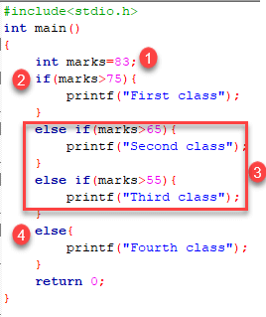
- We have initialized a variable with marks. In the else-if ladder structure, we have provided various conditions.
- The value from the variable marks will be compared with the first condition since it is true the statement associated with it will be printed on the output screen.
- If the first test condition turns out false, then it is compared with the second condition.
- This process will go on until the all expression is evaluated otherwise control will go out of the else-if ladder, and default statement will be printed.
Try modifying the value and notice the change in the output.
Summary
- Decision making or branching statements are used to select one path based on the result of the evaluated expression.
- It is also called as control statements because it controls the flow of execution of a program.
- 'C' provides if, if-else constructs for decision-making statements.
- We can also nest if-else within one another when multiple paths have to be tested.
- The else-if ladder is used when we have to check various ways based upon the result of the expression.

What is a Switch Statement?
A switch statement tests the value of a variable and compares it with multiple cases. Once the case match is found, a block of statements associated with that particular case is executed.
Each case in a block of a switch has a different name/number which is referred to as an identifier. The value provided by the user is compared with all the cases inside the switch block until the match is found.
If a case match is found, then the default statement is executed, and the control goes out of the switch block.
In this tutorial, you will learn-
- What is a Switch Statement?
- Syntax
- Flow Chart Diagram of Switch Case
- Example
- Nested Switch
- Why do we need a Switch case?
- Rules for switch statement:

Syntax
A general syntax of how switch-case is implemented in a 'C' program is as follows:
switch( expression )
{
case value-1:
Block-1;
Break;
case value-2:
Block-2;
Break;
case value-n:
Block-n;
Break;
default:
Block-1;
Break;
}
Statement-x;
- The expression can be integer expression or a character expression.
- Value-1, 2, n are case labels which are used to identify each case individually. Remember that case labels should not be same as it may create a problem while executing a program. Suppose we have two cases with the same label as '1'. Then while executing the program, the case that appears first will be executed even though you want the program to execute a second case. This creates problems in the program and does not provide the desired output.
- Case labels always end with a colon ( : ). Each of these cases is associated with a block.
- A block is nothing but multiple statements which are grouped for a particular case.
- Whenever the switch is executed, the value of test-expression is compared with all the cases which we have defined inside the switch. Suppose the test expression contains value 4. This value is compared with all the cases until case whose label four is found in the program. As soon as a case is found the block of statements associated with that particular case is executed and control goes out of the switch.
- The break keyword in each case indicates the end of a particular case. If we do not put the break in each case then even though the specific case is executed, the switch will continue to execute all the cases until the end is reached. This should not happen; hence we always have to put break keyword in each case. Break will terminate the case once it is executed and the control will fall out of the switch.
- The default case is an optional one. Whenever the value of test-expression is not matched with any of the cases inside the switch, then the default will be executed. Otherwise, it is not necessary to write default in the switch.
- Once the switch is executed the control will go to the statement-x, and the execution of a program will continue.

Flow Chart Diagram of Switch Case
Following diagram illustrates how a case is selected in switch case:
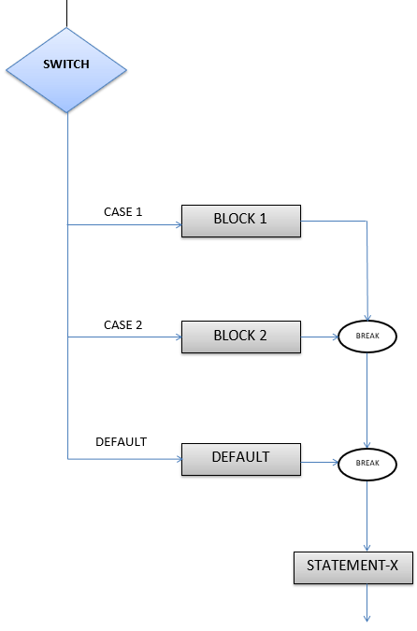How Switch Works

Example
Following program illustrates the use of switch:
#include <stdio.h>
int main() {
int num = 8;
switch (num) {
case 7:
printf("Value is 7");
break;
case 8:
printf("Value is 8");
break;
case 9:
printf("Value is 9");
break;
default:
printf("Out of range");
break;
}
return 0;
}
Output:
Value is 8
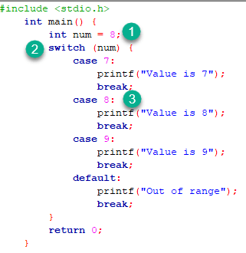
- In the given program we have initialized a variable num with value 8.
- A switch construct is used to compare the value stored in variable num and execute the block of statements associated with the matched case.
- In this program, since the value stored in variable num is eight, a switch will execute the case whose case-label is 8. After executing the case, the control will fall out of the switch and program will be terminated with the successful result by printing the value on the output screen.
Try changing the value of variable num and notice the change in the output.
For example, we consider the following program which defaults:
#include <stdio.h>
int main() {
int language = 10;
switch (language) {
case 1:
printf("C#\n");
break;
case 2:
printf("C\n");
break;
case 3:
printf("C++\n");
break;
default:
printf("Other programming language\n");}}
Output:
Other programming language
When working with switch case in C, you group multiple cases with unique labels. You need to introduce a break statement in each case to branch at the end of a switch statement.
The optional default case runs when no other matches are made.
We consider the following switch statement:
#include <stdio.h>
int main() {
int number=5;
switch (number) {
case 1:
case 2:
case 3:
printf("One, Two, or Three.\n");
break;
case 4:
case 5:
case 6:
printf("Four, Five, or Six.\n");
break;
default:
printf("Greater than Six.\n");}}
Output:
Four, Five, or Six.

Nested Switch
In C, we can have an inner switch embedded in an outer switch. Also, the case constants of the inner and outer switch may have common values and without any conflicts.
We considere the following program which the user to type his own ID, if the ID is valid it will ask him to enter his password, if the password is correct the program will print the name of the user, otherwise ,the program will print Incorrect Password and if the ID does not exist , the program will print Incorrect ID
#include <stdio.h>
int main() {
int ID = 500;
int password = 000;
printf("Plese Enter Your ID:\n ");
scanf("%d", & ID);
switch (ID) {
case 500:
printf("Enter your password:\n ");
scanf("%d", & password);
switch (password) {
case 000:
printf("Welcome Dear Programmer\n");
break;
default:
printf("incorrect password");
break;
}
break;
default:
printf("incorrect ID");
break;
}
}
OUTPUT:
Plese Enter Your ID:
500
Enter your password:
000
Welcome Dear Programmer
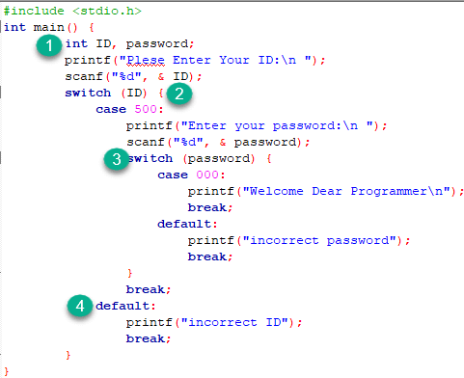
- In the given program we have initialized two variables: ID and password
- An outer switch construct is used to compare the value entered in variable ID. It execute the block of statements associated with the matched case(when ID==500).
- If the block statement is executed with the matched case, an inner switch is used to compare the values entered in the variable password and execute the statements linked with the matched case(when password==000).
- Otherwise, the switch case will trigger the default case and print the appropriate text regarding the program outline.

Why do we need a Switch case?
There is one potential problem with the if-else statement which is the complexity of the program increases whenever the number of alternative path increases. If you use multiple if-else constructs in the program, a program might become difficult to read and comprehend. Sometimes it may even confuse the developer who himself wrote the program.
The solution to this problem is the switch statement.

Rules for switch statement:
- An expression must always execute to a result.
- Case labels must be constants and unique.
- Case labels must end with a colon ( : ).
- A break keyword must be present in each case.
- There can be only one default label.
- We can nest multiple switch statements.

Summary
- A switch is a decision making construct in 'C.'
- A switch is used in a program where multiple decisions are involved.
- A switch must contain an executable test-expression.
- Each case must include a break keyword.
- Case label must be constants and unique.
- The default is optional.
- Multiple switch statements can be nested within one another.

